Skyrun Customer Analysis: Findings & Recommendations
Oct 27, 2026 · @AMDARI

Executive summary
Skyrun’s 4,372 identified customers generated about 1.04 billion in revenue between 1 December 2024 and 9 December 2025. A small group does a lot of the work: 272 customers (6%) account for about 36% of revenue. At the other end, only about 1 in 5 new customers buys again in the month after their first purchase, and one customer in four has gone quiet. Growth therefore depends on a loyal core, a steady flow of new buyers, and turning more first-time buyers into repeat customers.
Headline findings
- Value is concentrated: the 6 Ultra-VIPs and 266 Regulars (6% of customers) bring in about 36% of revenue.
- The biggest pool of growth is Good Customers: 3,023 customers (69%) generate about 57% of revenue but order only about 4 times each.
- New customers rarely return quickly: only 19–25% of customers acquired between January and August 2025 bought again the following month.
- A quarter of customers have gone quiet: 1,077 At Risk / Lost customers (25%) have ordered about 2 times and have not bought for 249 days on average. They account for about 7% of revenue.
Top recommendations
- Launch a second-purchase programme for new customers, within 14–30 days of their first order.
- Move Good Customers up a level with personalised recommendations, bundles and spend-based perks.
- Protect the Regulars and Ultra-VIPs with loyalty benefits, and a named account manager for the 6 Ultra-VIPs.
- Run a low-cost win-back campaign for At Risk / Lost customers, and stop contacting anyone who does not respond.

Background and data
Skyrun has been very good at winning new customers, but retention has fallen over the past 18 months: many first-time buyers never return, which weakens lifetime value and makes acquisition spend harder to justify. This analysis set out to answer three questions: who are Skyrun’s most valuable customers, how well do customers come back after their first purchase, and where is revenue at risk?
Item | Value
Source file | Skyrun dataset.csv (transaction lines)
Period covered | 1 December 2024 – 9 December 2025
Customers analysed | 4,372 customers with a customer ID
Monthly cohorts | 13 (customers grouped by first-purchase month, December 2024 – December 2025; December 2025 covers 9 days only)
Customer segments | 4 (from recency, frequency and monetary spend)
Rows removed | 135,080 rows with no customer ID (25% of rows)
We removed rows without a customer ID because they cannot be linked to a customer, so every figure in this report covers identified customers only. Revenue was calculated as quantity × unit price. No rows had a zero or negative quantity or unit price, so no returns or cancellations needed removing.

Methodology
The analysis used three methods, all in Python (pandas, scikit-learn, seaborn).
- Exploratory analysis: customers by country and revenue by month.
- Cohort retention: each customer was assigned to the month of their first purchase. Retention is the share of that cohort that bought again in each later month.
- RFM segmentation: for each customer, the analysis measured:
  - Recency: days since the last purchase, counted from the day after the last transaction in the data
  - Frequency: number of orders (invoices) in the period
  - Monetary: total revenue from the customer
We standardised the three measures and grouped them with K-Means into 4 clusters. The number of clusters was chosen with the elbow method (k = 2–10). Each cluster was then named from its average profile.
In plain terms: customers are grouped by how recently they bought, how often they buy and how much they spend, and each group is then given a descriptive name.

Key findings

1. A small group of customers drives a large share of revenue
Customers fall into four clear groups. The table shows how large each group is, how recently and how often it buys, and how much of Skyrun’s revenue it brings in.
Segment | Customers | Share of customers | Avg days since last order | Avg orders | Avg spend per customer | Share of revenue
Ultra-VIPs | 6 | 0.1% | 2 | 154 | 12.3M | ~7%
Regulars | 266 | 6% | 12 | 25 | 1.12M | ~29%
Good Customers | 3,023 | 69% | 43 | 4 | 195K | ~57%
At Risk / Lost | 1,077 | 25% | 249 | 2 | 69K | ~7%
Revenue shares are approximate: they are calculated from each group’s average spend and size. Average orders and days since last order are shown for the whole period.
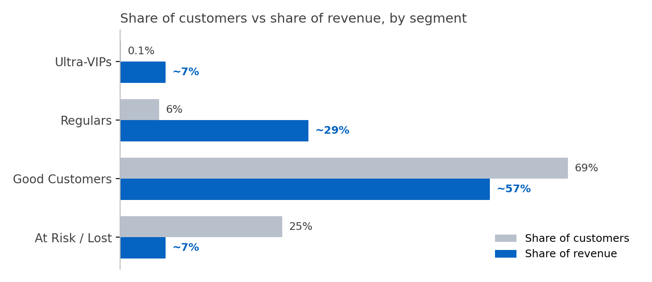
- Ultra-VIPs (6 customers) order about 154 times each and bought within the last 2 days on average. Each one is worth about 1% of total revenue, so losing even one is noticeable.
- Regulars (266) order about 25 times each and are recent buyers. They are 6% of customers but bring in about 29% of revenue, so keeping them buying is cheaper than replacing them.
- Good Customers (3,023) are the bulk of customers (69%) and about 57% of revenue, yet order only about 4 times each. Moving them toward Regular behaviour is the largest growth opportunity.
- At Risk / Lost (1,077) have ordered about 2 times and have not bought for around 8 months on average. They bring in only about 7% of revenue, so win-back effort here should stay low-cost.

2. Most customers do not come back after their first month
Each row below is a group of customers who made their first purchase in the same month. Each number shows the share of that group who bought again in a later month. Month 1 is the first-purchase month (always 100%) and Month 2 is the month after it.
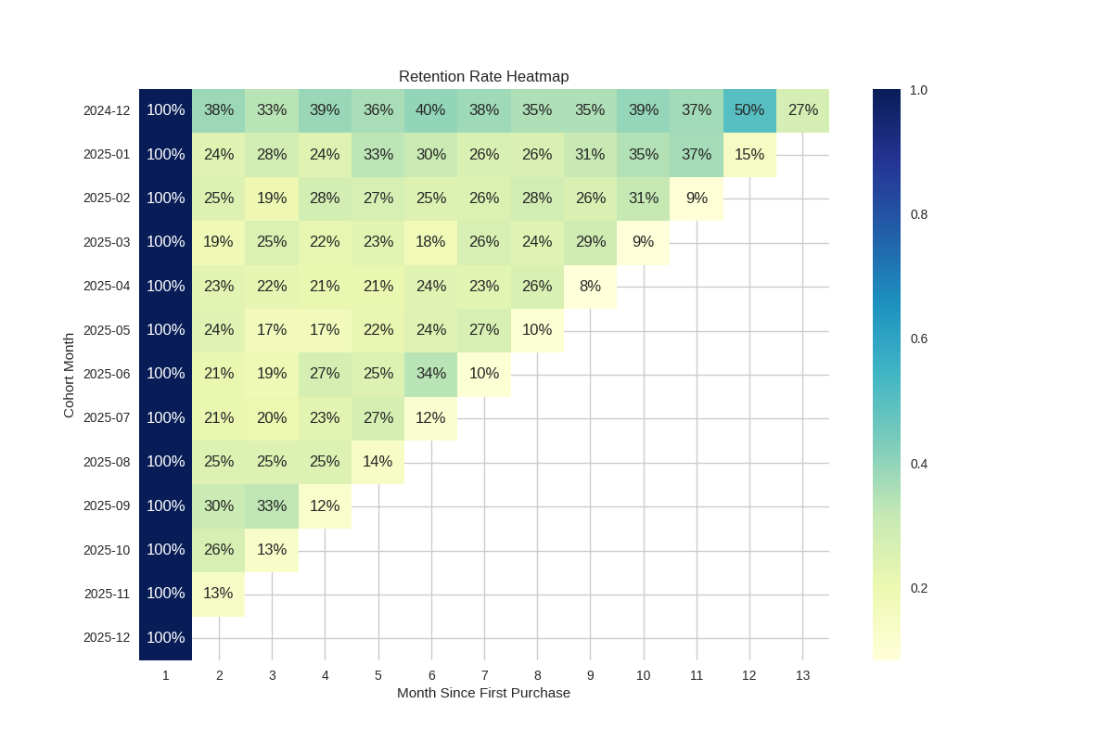
- Roughly 3 in 4 to 4 in 5 new customers do not return the next month. Only 19–25% of the January to August 2025 cohorts bought again in Month 2.
- Customers who do return tend to keep buying. After Month 2, 17–37% of each 2025 cohort buys in any given month, so retention levels off rather than falling steadily.
- December 2024 looks stronger (33–50%) but is not a fair comparison. It is the first month of data, so it probably includes established customers who were not new that month. We left it out of the trend comparison.
- Recent cohorts are still maturing. Month 3 retention dipped from 28% (January cohort) to 17% (May cohort) but recovered to 33% for September, so there is no clear downward trend. The September to December cohorts have had little time to return, and the last value in most rows (8–15%) is low only because December 2025 covers 9 days.

Recommendations
The recommendations are ranked by expected impact on revenue and retention. Owners and targets in square brackets are suggestions to agree with the team.
# | Recommendation | Segment | Why | KPI | Owner | Target
1 | Send a second-purchase offer 14–30 days after the first order, with a recommendation based on what they bought | New customers | Only 19–25% of new customers buy again in Month 2; 25% of customers are At Risk / Lost, averaging about 2 orders | Month-2 retention | [Owner] | [e.g. 23% → 30%]
2 | Use personalised recommendations, bundles, free-delivery thresholds and replenishment reminders to raise order frequency | Good Customers (3,023) | 69% of customers and about 57% of revenue, but only about 4 orders each | Orders per customer | [Owner] | [e.g. 4 → 6 orders]
3 | Launch a tiered loyalty programme (points, early access, free delivery) | Regulars (266) | 6% of customers bring in about 29% of revenue; keeping them is cheaper than replacing them | Orders per customer; share still active | [Owner] | [e.g. 25 → 28 orders]
4 | Assign a named account manager, offer early access and set an alert when an order gap gets longer than usual | Ultra-VIPs (6) | About 7% of revenue from 6 accounts; each is worth about 1% of the total | Ultra-VIP retention | [Owner] | [e.g. 6 of 6 retained]
5 | Run a low-cost win-back campaign (time-limited offer, “we miss you” email) and stop contacting anyone who does not respond | At Risk / Lost (1,077) | 249 days since last order on average; only about 7% of revenue, so keep spend low | Reactivation rate; cost per reactivated customer | [Owner] | [e.g. 10% reactivated]
6 | Track the quality of newly acquired customers by cohort and by acquisition channel or promotion | New customers | Month 3 retention ranges from 17% to 33% across cohorts; promotions may bring in one-time buyers | Month-2 and Month-3 retention by cohort and channel | [Owner] | [Target]
7 | Test each programme against a control group, and add acquisition cost and margin data | All | Without a control group, we cannot tell whether an offer caused extra purchases; cost data is needed to estimate customer lifetime value | Uplift vs control group; CLV to CAC | [Owner] | [e.g. +5 points]

Limitations and next steps
Limitations
- Missing customer IDs: 135,080 rows (25%) without a customer ID were removed, so all figures cover identified customers only.
- Young and partial cohorts: the latest cohorts have had little time to return, and the December 2024 cohort likely includes existing customers.
- Partial final month: December 2025 covers only 1–9 December. This lowers the last value in each row of the retention heatmap; it is not a real drop in loyalty.
- Segment sizes and names: the clustering method (K-Means) is sensitive to extreme values, and one segment holds only 6 customers. Results could shift with different settings. Revenue shares are estimated from segment averages.
- No cost data: acquisition cost and margin are not in the dataset, so customer lifetime value and return on marketing spend cannot be measured yet.
Next steps
- Measure how long customers wait between orders, to time the second-purchase and win-back messages accurately.
- Repeat the segmentation on log-transformed spend and frequency, to check that the groups are stable and the 6-customer segment is not an artefact.
- Break retention down by country and first-purchase category to find which customers are most likely to return.
- Pilot the second-purchase offer with a control group before rolling it out.

